
SUNBURST TECHNOLOGY CORPORATION
Team #1-Sunflower
ge401_402@googlegroups.com

FINAL REPORT
28.12.2010

İrem Akdaş-IE Ali Öztaş-CS Betül Örün-EE
20602266 20701569 20700796

Nil Tuğçe Patan-IE(MAN) Berkay Öğdük-CS Tuğçe Kartalkanat-EE
20603256 20702282 20603276

Bilkent University
06800 Ankara
Version 1.1

Table of Contents
- Abstract............................................................................................................... 3
- Introduction……………………………………………………………………. 4
- Starting the Company…………………………………………………………. 5
  - Vision, Mission……………………………………………………... 5
  - Illustrating Product Process ……………...………………………… 5
  - Company Organization……………………………………………... 6
- Business Plan Overview………………………………………………………....7
- Project Scheduling……………………………………………………………….8
- Quality Function Deployment (QFD)…………………………………………..10
- Developments in the Project.…………………………………………………...12
- Professional and Ethical Issues…………………………………………………13
- The Expected Impact of Our Project……………………………………………16
  - Impact of our project at a global scale………………………………16
  - Societal Impact of Our Project……………………........……………16
- Conclusion……………………………………………………………………....17
Appendices……………………………………………………………………...19
Works Cited……………………………………………………………………..29

- Abstract
The aim of this report is to illustrate the work done during fall semester by all group members. The process of starting a company with the product of innovative parasol which is designed within the control of supervisors is given. The steps of the starting the Sunburst Company is given as institutional works. The next steps are basically developing the engineering structures and developing business plan at the same time. Company’s attitude towards quality and professional and ethical issues are given next.

Introduction
Since the development of technology and its integration to the daily lives is getting important, the usage of innovative product is becoming one step further in advance. So as to catch up with the contemporary world, the new companies should focus on to develop their technological perspective. Taking this idea as a roll model, we started a company which produces innovative parasol. The main aim of that product is to response to the sun and to integrate people’s luxury understanding. The design of that parasol is done by group members within the control of supervisors. The expectations of supervisors and group members are important for that project but we give importance to the costumers needs too. With the help of the survey, we got opportunity to observe weaknesses and strengths of the parasol design. We know that having a unique product design is not enough for a company for development. Therefore, we also focused on institutional works such as organizational chart, vision, mission, etc. at the same time and demonstrated our business plan.

3. Starting the Company
3.1 Vision, Mission
The beginning idea of the parasol is to rotate according to the sun and response to the rain at the same time in the beginning. In accordance with this unique idea, we decided to start our company as 6 engineering students. The institutional works were given importance and vision, mission was decided according to our expectations, capabilities and future plans. Our mission is to integrate technology and creativeness into products and deal with competitive circumstances’ so as to offer comfort to the costumers continuously. The vision is staying unique in the market and being leader in this area around the world.
  - Illustrating Product Process
Although parasols are not certain requirement for daily life there is an important parasol market in Turkey. The reason is that, parasols are preferred almost everywhere like hotels, pools, cafeterias, individuals’ house etc. As in stated literature survey and competition report the diameter, color, water repellent fabric features, water capacity of containers and number of slice domestic polyester skeleton, digital printing on the roof cover vary in terms of the consumer choice, environment design and personnel preferences. The costumers have opportunity to clarify their needs and expectations so there are no problem to find the most suitable parasol according to their needs. As Sunburst Company, we are aware that these requirements must be satisfied in this market area. Within the direction of our vision and mission, our parasol design has ability to rotate according to the sun. It will bend from its stick and response to the sunlight.
According to our market analysis, it can be definitely clarified that we do not have any direct competitors in this area. The idea of the innovative product is new. Therefore when we want to evaluate our current situation, we compare it with our expectations instead of competitors.
  - Company Organization
Sunburst Company is founded by 6 engineering students. Since our study area is different from each other, the job division was done according to our study disciplines.
We do not have any graphic designer in the company. Therefore, computer science members took responsibility to design corporate identities such as envelope letter, business card, company logo etc. They were designed according to the aim of the innovative product and chosen among a few alternatives.
The organizational chart is given below:
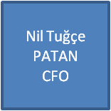
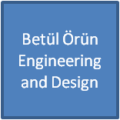
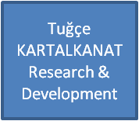
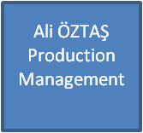
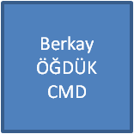
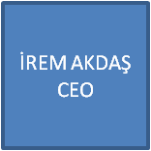
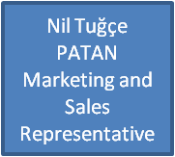
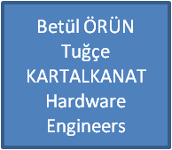
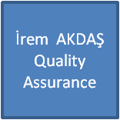





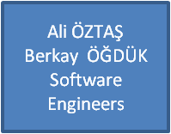

- Business Plan Overview
Business plan was decided by all group members and written by chief financial officer. In the final report of the business plan it is clarified that “we need 1.500.000TL capital for our manufacturing facilities. Our head office will be in Cyberpark for advanced R&D studies because of the fact that we are an innovative company.” The budget and location are stated in that way.
Sunflower parasol is an innovative product and it will take time to involve to the costumers daily lives immediately. By taking this into consideration, we classify that product as luxury goods and our business plan is shaped within the border of that thought. Approximately 5 years later, the blue collar workers will be assembling the parasol. In other words, we plan to start mass production. Since the location is stated as Cyberpark, we do not have huge storage area. Therefore, just in time (JIT) technique will be applied which is the product will be done after the ordering process. The other benefit of JIT is that the costumers clarifies their needs such as diameter, color preferences and producing parasols before evaluating costumers preferences can cause the waste of energy and material in such cases. We are aware that in order to start mass production we have to prepare our budget and sales must be done in accordance.
We have unique parasol design but we have to investigate the existing competition in Turkey. After the investigation process we clarified that there are 17 companies and Celal Birsen is the leading parasol company in Turkey. The other parasol companies are sequenced as İstanbul Şemsiye Sanayi, Özcan, Özstar, Şahin, Robenson, and Mega. As a result of our analysis we determined the targeted sales as both in the winter and summer season.
The price is one of the most important issues which have to be determined carefully. Fixed and variable costs are taken into consideration. Weighted average method and first in first out method (FIFO) were applied. We have to be careful about undercosting and overcosting so we illustrated the spending with great effort. After the financial statements the total cost of producing the parasol is 1600 TL. The cost is found a little bit much by group members taking the willingness of the costumers into consideration. Since the future plans are done according to the 5 years we expect the range of the price as 406TL to 1450TL.The reduce of the price is due to the quality and possible applications.

- Project Scheduling
Project scheduling has big role in determining the timing. Starting from the foundation of the company to finishing and demonstrating the product project timing is very crucial. With the help of the MS Project, we determined 8 workpackages. Under these workpackages, we clarified what kind of jobs should be done. Some of the jobs has precedence and the other should be done in accordance with the other. Taking all of the relations into consideration like start-to-start, start-to-finish etc. we determined the finishing and starting times of the each job. These jobs and Gant Charts are demonstrated in the Development Plan report with depth analysis. Holidays and weekends are considered as working days so that we could discuss and continue our job all the time.
The workpackages and their sub headings are illustrated below:
TASK NAME DURATION (days)
1. Institutional Works 12
Preproposal 2
Approval of Preproposal 4
Determination of Project 4
Company Name 2
Job Division 2
2. Research 29
Market Research 21
Competitor Analysis 14
Competition Report 7
Literature Survey 7
Hardware Research 16
HW Block Diagram 8
HW Search 8
Software Research 8
User Interface 8
SW Flow Chart 8
3. Business Plan 72
Organizational Plan 17
Organizational schema 2
Location 6
Products & Services 6
Future Plans 17
Performance Evaluations 6
Financial Plan 48
Financial analysis 35
Balance Sheet 4
Break Even 4
Financial Ratios 5
Income Statement 3
Assets 30
Marketing Plan 48
Sales Strategy 8
Buying Decisions 48
General form 7
4. Engineering 50
Product Definition 6
Product Specification 8
Subassembly Specification 23
Product Definition with QFD 6
Prototype Demonstration 1
Web Pages 9
5. Implementation 23
6. Testing 63
7. Marketing plan 30
Challenge 6
Costumer analysis 11
Competitor analysis 5
Market Segmentation 16
Market Strategy 3
8. Industrialization 51
Production Document 5
Costumer Document 4
Quality Control 31

As clarified in the Development Plan in detail, the project officially starts at 14.09.2010 and finishes at 17.05.2011. Our expectation is that we will finish the product before the spring semester ends.

- Quality Function Deployment (QFD)
Companies’ attitude towards quality states the future position of the product in the market. As Sunburst Company we give vital importance to quality. In order to get configuration, we report our meetings and they are ready for the spring semester to get quality configuration. All of the written reports have versions more than one so that we can improve ourselves and integrate our and supervisors’ new ideas into the parasol.
In addition to them we have prepared Quality Function Deployment (QFD) report. Before starting to that report, we wanted to investigate the costumers’ needs. Therefore, we conducted a survey which directly aims to learn expectations from a parasol as a costumer. In the process of evaluating the results of the survey, we wanted to get personal information of participants like monthly income, age interval and having engineering background or not. The reason of why we wanted to learn is to decide our target costumers and improve weaknesses by giving more importance to the participants’ response who has engineering background. (See appendix A for survey)
The survey results showed us that cost carries too much importance for the costumers. Because of the fact that our parasol is an innovative product, its price is higher than the others which have already took place in the market. Some of the participants stated that they are willing to pay for this product but most of the participants think that too much cost do not worth for a parasol. Easiness to carry and after sale services are not important that much as we expected. We investigated the reason of it and we realized that most of the people do not evaluate that parasol like a device and their expectations are lower as a result of this. Additionally, reliability against weather conditions is a vital criterion for costumers. Power supply and interface of the product are also important. The potential costumers stayed indifferent to answer this question so at that point we give importance to the participants who have engineering background. By evaluating all of the answers and as demonstrated in the product definition report we concluded the following chart:
Costumer Requirements “WHATS” Importance Rating
Cost 4
Easy to carry 3
After sales service 3
Reliability against weather conditions 4
Diameter of the parasol 2
Interface 3
Duration of the power supply 4

The next step was to investigate which methods could be done to reach our goal. After discussing the methods we stated that user friendly interface, cost standardization, consulting services, offering alternative choices and durability of the components will be effective and applicable. Combining the results of WHATS and HOWS according to the needs, we demonstrated relationship matrix. (See Appendix B to Relationship Matrix)

7. Developments in The Project
Decide the angle of the parasol
At the beginning of the project, we had decided to use camera instead of light dependent resistors to determine the position of the parasol according to sunlight. We had decided to use camera to apply image processing but in order to use this method we had to buy an expensive camera. So we have changed our decision and decided to use LDRs. Light Dependent Resistors are more more cheaper than cameras and this method is the easiest way to determine the angle of the parasol.
Power supply
In the first steps of the process, power supply of the parasol would be city electricity. However, we have changed our mind and decided to use battery instead of city electricity since city electricity may be very dangerous near the seaside. Also, battery is more useful because if we use battery as power supply users can move parasols to where they want.
Microprocessor
We had decided to use PC104 as a microcontroller while planning to use camera instead of light dependent resistors. However, during the design process, we have decided to use LDRs so we were obliged to change the microprocessor. So we have decided to use 8051 microprocessor. 8051 is cheaper than PC104 so we could save thanks to this decision.

Prototype
In our prototype we had displayed the ability of determining angle of the sunshine of our parasol. To visualize this, we had prepared a mechanism with motor, hydraulic pipe and elbow. We used hydraulic pipe because this kind of pipe is heavier than other pipes and we wanted to measure the ability to withstand the weight of our parasol.

8. Professional and Ethical Issues

1-IP :( Intellectual Property infringement policy)
- For the software part; as a policy decision, we first started to write the assembly code by the companies software engineers and our 2 software engineers wrote the assembly code without any help from the outside sources. That’s why, in the first generation of our company, we did not deal with the copyright issues. At the later stages, we hired some engineers and educated them according to the implementation of the code and we applied some policies regarding to the copyright issue of the software. As a result of it, we decided to make a certain rule in which the worker will be fired from the company if it is understood that he/ she did not respect to the laws of the company and try to use the algorithm outside of the company to his/ her purpose. On the other hand, the algorithm is related with the code and since the algorithm was written by the software engineers of the company, it can be understood that the algorithm was written without the help of other resources and that’s why it does not infringe copyright. The algorithm of our software is simple but as a policy decision, like in the case of the assembly code, the usage of the algorithm without the benefits of the company is forbidden.
- For the policy decisions of hardware, it can be said that the sunflower consists of a motor, LDRs, ATMEL 8051 microcontroller, 2 buffer, 4 relay, analog to digital converter, 12v battery and some circuit elements. The motor is responsible for rotating the parasol according to the results of the LDR. LDRs are responsible for sensing the sunlight and gives results according to the light intensity. The policy decision that our company did for the hardware parts is that the hardware is designed by our hardware designers and we are sure that the hardware does not infringe patent rights of others.
- Our company has Basic Nondisclosure Agreement. Which briefly includes :
Non-Disclosure Agreement
1. Confidential Information: Confidential information means any information disclosed to by one party to the other, either directly or indirectly in writing, orally or by inspection of tangible or intangible objects, including without limitation documents, business plans, source code, software, documentation, financial analysis, marketing plans, customer names, customer list, customer data
2. Maintenance of Confidentiality Information: The Receiving Party agrees that it shall take all reasonable measures to protect the secrecy of and avoid disclosure and unauthorized use of the Confidential Information. Without limiting the foregoing, Receiving Party shall take at least those measures that Receiving Party takes to protect its own most highly confidential information and shall have its employees, if any, who have access to Confidential Information sign a non-use and non-disclosure agreement in content substantially similar to the provisions hereof, prior to any disclosure of Confidential Information to such employees. The Receiving Party shall not make any copies of Confidential Information unless the same are previously approved in writing by the Disclosing Party. The Receiving Party shall reproduce the Disclosing Party's proprietary rights notices on any such approved copies, in the same manner in which such notices were set forth in or on the original. The Receiving Party shall immediately notify the Disclosing Party in the event of any unauthorized use or disclosure of the Confidential Information.
3. No Obligation: Nothing herein shall obligate either party to proceed with any transaction between them, and each party reserves the right, in its sole discretion, to terminate the discussions contemplated by this Agreement concerning the business opportunity.
4. Return of Materials: All documents and other tangible objects containing or representing Confidential Information and all copies thereof which are in the possession of Receiving Party shall be and remain the property of the Disclosing Party and shall be promptly returned to the Disclosing Party upon the Disclosing Party's request.
5. No License: Nothing in this Agreement is intended to grant any rights to either party under any patent, mask work right or copyright of Company, nor shall this Agreement grant Receiving Party any rights in or to Confidential Information except as expressly set forth herein.

9. The expected impact of our Project:
9.1. Impact of our project at a global scale
Our product, Sunflower is a brand new innovative product. It changes the way of life in an innovative way. Since it can provide shadow continuously and protect from rain and sunlight without any human effort, Sunflower will easy the life of individuals. We expect to create a new approach to parasol market. In addition to them, our product is luxury consumption good and according to industry analysis, there exists an increasing demand on luxury consumer goods around the world.
9.2. Societal impact of our Project:
The effect of our product on the society can be stated as comfort, prestige, quality level
and design. Sunflower is the unique way of serving customers. The comfort of our parasol will make hotels’ and restaurants’ business one step further in their marketing. On personal life, the affect of Sunflower can be stated as Sunflower will easy the life of individuals. In addition to them, since smoking prohibited, the needs for outdoor parasol are highly increased. At this point, our product will easy the life of individuals both in summer and winter months. Actually, its properties are beyond the customer demands. The color preference and unique design for each customer properties will make our parasol desirable in every place.

10. Conclusion

Sunburst Corporation is a company which produces sunflowers in order to protect the customers from the sun in the summer and with its rain sensor button, it has a function to open its parasol when it rains. The product is prepared for the hotels which serves a lot of customers in the summer.
While designing this product, we had a lot of changes in our design and ideas because in the beginning of the design phase, we think that using the sunflower and enabling it to open and close by using a remote controller with a computer can be the best solution for our design but later we noticed that by doing that we increase cost. In order to decrease the cost and produce something that everyone affords to buy, we dropped the remote controller out of the design and instead of it, we added a button that the customer pushes when he/ she wants to open the parasol and according to the intensity of the sunlight, our algorithm rotates the parasol so that the customer is protected from the sun. Another think we obtained from the experiments that we should create a product which differs from its contenders and as a result of it, we added a function which protects the customer also from the rain. The button which enables parasol to open is activated by the user when it rains and by adding this function, we try to have a product which differs from other parasols as well.
On the other hand, after the production, newly contenders will be in the market and cost will become the most important criterion for our company because we should decrease the cost as much as possible in order to win the race between our contenders. This issue will be discussed in the latest stages because we should first find the optimal cost for our product and later, we should develop it by decreasing cost.

Dedication to Professional Development of Employees and Apprentices

Our company needs a lot of engineers as a result of its aim because production plays a big role in the development stage of the company. That’s why; employees and apprentices have a huge impact in the company. We believe that a well-educated engineer can be more productive in the sense of creating ideas and implement them. Our mechanism is simple and we try to design a product which is more functional and has less cost. Consequently, a well-educated engineer can play a big role in the development of the company and the problem-solving stages of the company.

Appendices
Appendix A
Survey
General Information: Sunflower parasol has a unique parasol design which can rotate according to the sun and response to the rain. This design will be introduced to the market a few months later and it will be unique because of its qualifications. Please complete this 5 minutes survey.

PART 1: Personal Information

- My age interval is

a. 18-25 b. 26-35 c. 36-50 d. 51+

- My personal income in a month is

  - Below $500
  - $500-$1000
  - $1001-$5000
  - $5000 +

- I am an engineering student

  - Yes
  - No

PART 2: Usage Specifications
Please select one of the ratings according to your expectations from a parasol.
1→extremely ineffective 2→ ineffective 3→neutral 4→effective 5→extremely important
1 2 3 4 5
- Cost □ □ □ □ □

5. Easy to carry □ □ □ □ □

6. After sales service □ □ □ □ □

7. Reliability against weather conditions □ □ □ □ □

8. Diameter of the parasol □ □ □ □ □

PART 3: Technical Specifications
Please select one of the ratings according to your expectations from a parasol.
1→extremely ineffective 2→ ineffective 3→neutral 4→effective 5→extremely important
1 2 3 4 5
9. User friendly interface □ □ □ □ □

10. Duration of the power supply □ □ □ □ □

Thanks for completing the survey!

Appendix B
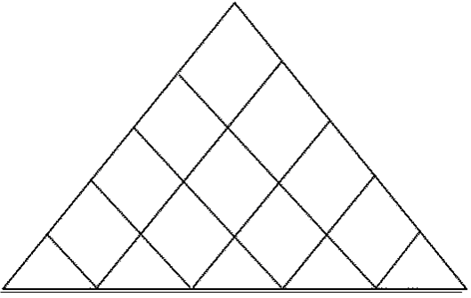
+ +
-
+
- -
- -
+
+
-
Direction of Improvement
HOWS  WHATS | Rank of  Importance | User friendly interface | Cost standardization | Consulting services | Alternative choices | Durability of components
Cost | 4 |  | ▲ |  | ■ | ▲
Easy to carry | 3
After sales service | 3 | ▲ | ■ | ▲ | ◙
Reliability against weather conditions | 4 |  |  | ◙ |  | ▲
Diameter of the parasol | 2 |  |  |  | ▲
Interface | 3 | ■ |  |  | ▲
Duration of the power supply | 4 |  |  | ◙ | ■ | ◙
▲ (Strong)
■ (Medium)
◙ (Weak)

Appendix C
9.1 CHANGES IN THE PRODUCT DEFINITION REPORT
As mentioned before in “Developments in the Project” part, we have changed our method to detect the angle of sunrays completely. At first time, we were planning to use camera and PC104 Embedded PC Module. We would track the sun with the camera by image processing. However, we made some researches, got advices from our assistants and agreed on that using light dependent resistors and 8051 microcontroller is more practical, effective and cheaper than doing image processing. Therefore we changed our method and describe the new method in the second version of our product definition.
Moreover, we have realized that there is a problem with the rain sensor used in the product and no better sensor is available in the market. The problem is that, when the rain stops the surface remains wet for a while and the sensor cannot perceive that there is no rain anymore. This situation might cause a significant error rate in the operation. To prevent this situation, we decided to use a rain indicator LED and an extra button. We explained that situation and the usage of the button in the second version of the product definition.
At the beginning we were also planning to make the system operate via RS485 port. We thought that it would be beneficial for hotel, beach, and cafe owners to control all of the parasols by using a computer with RS485 port. Also we planned to convert and use city electricity. But later, we decided that using cables in the beaches for RS485 or electricity would be dangerous. Instead we decided to use buttons for the operation of the system and rechargeable battery to supply electricity to the system. Hence, our user interface is changed completely and we explained the new interface in the second version.
In the first report, we considered maximum wind speed as 80 km/h and calculated the wind load accordingly. We declared that we were to use 3 DC multifunctional motors. However, we learned from Tarık Reyhan that 80 km/h is so huge that even in the design of military equipment 75 km/h is assumed. Therefore, we assumed maximum wind speed as 40 km/h and revised the wind load accordingly in the second report. Additionally, we decided to use 2 DC multifunctional motors and 1 Qijintai DC Motor, since the multifunctional ones are too expensive and too powerful.
According to the comments of Tarık Reyhan on the first version, we added some missing information to the second version. We added cost of the product, physical environment in which the product will be used, operating temperature, water-proofness, time-to-open/close, power consumption of the product, rain rate for the rain sensor to operate, and physical characteristics of the parasol body such as weight and size. On the other hand, we excluded block diagram and flowchart diagram of the product in the second version, after learning that they are improper to include in product definition report. In addition, we revised our standards and replaced with more proper ones in terms of electromagneticity, safety and power.
Furthermore, we have implemented a survey and prepared “Quality Function Deployment” to define our weaknesses and strengths, and added this new part to the second version of the product definition.
Finally, we made some changes on the general outlook of the first version of the report. While preparing the first version, we did not have a company logo. In the second version, we watermarked our logo on the report.

9.2 CHANGES IN THE BLOCK DIAGRAM
We have improved the block diagram of the product in accordance with the changes in the methods and equipments and comments of Tarık Reyhan.
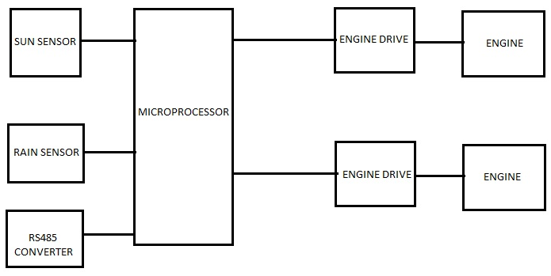
Figure 1: Block Diagram v1.1
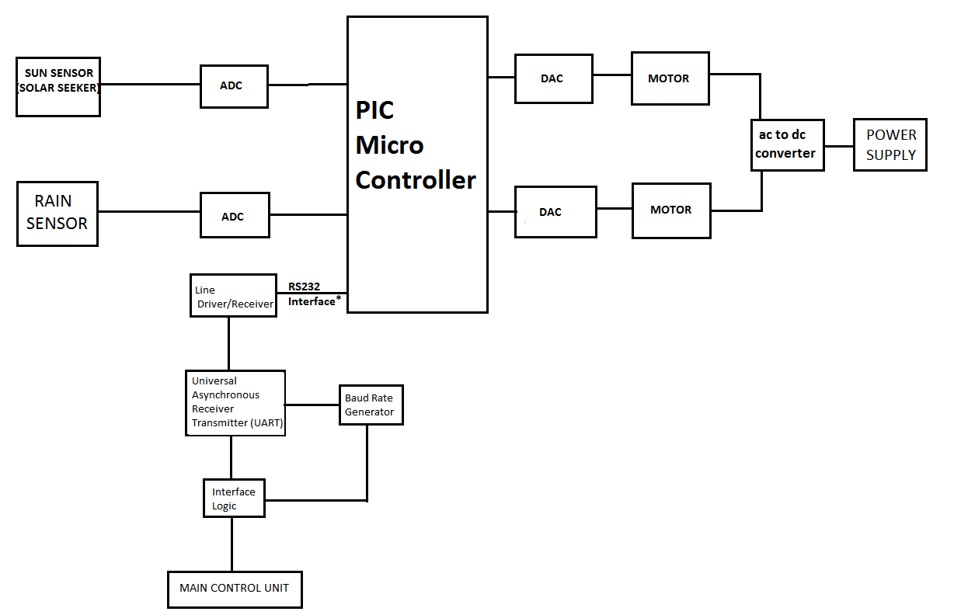
Figure 2: Block Diagram v1.2
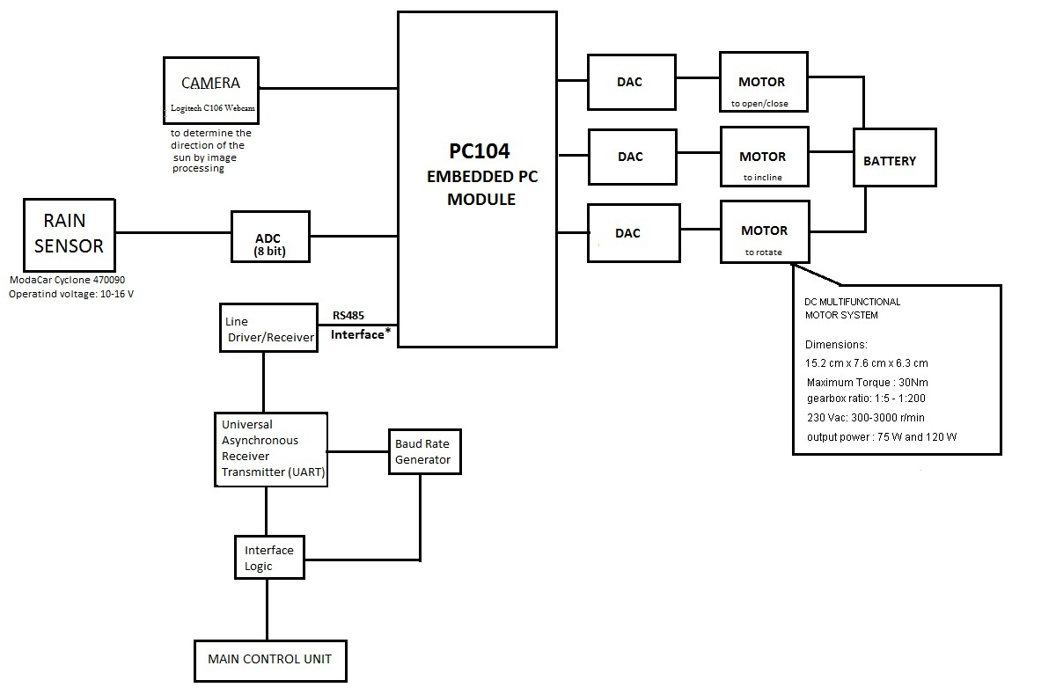
Figure 3: Block Diagram v2.1

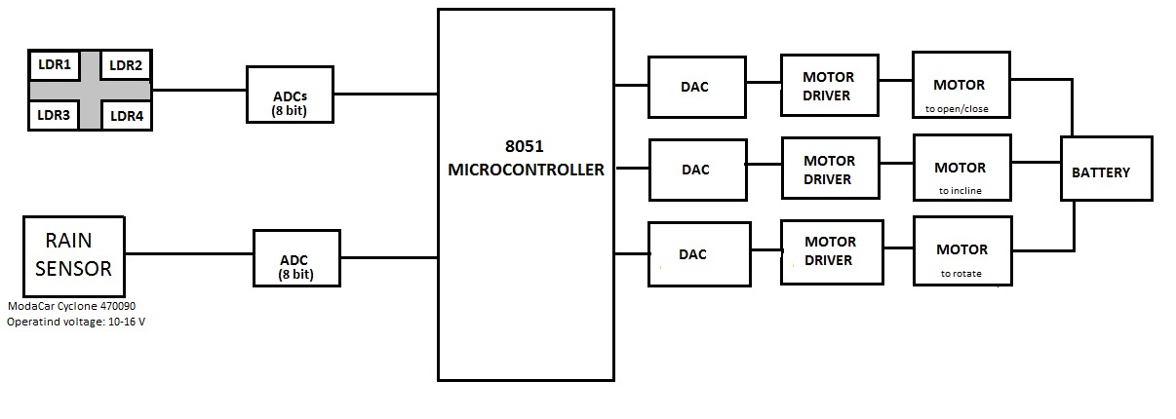
Figure 4: Block Diagram v3.1

9.3 CHANGES IN THE FLOWCHART DIAGRAM
We have redrawn the flowchart diagram of the product considering the changes in the operation process of the product. In other words, we replaced function of the RS485 module by a switch and an on/off button.

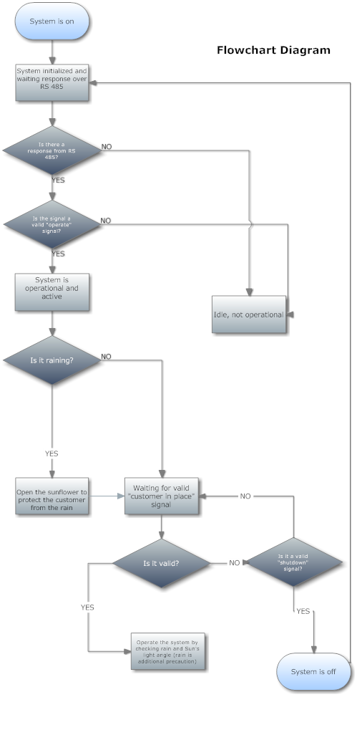
Figure 5: Flowchart Diagram v1.1

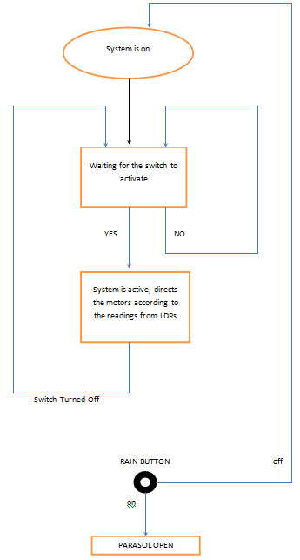
Figure 6: Flowchart Diagram v2.1
9.4 PHOTOS OF THE PROTOTYPE
For the prototype demonstration, we preferred to construct a system with a hydraulic pipe instead of a real parasol, since it is our first trial and we do not have sufficiently powerful motors yet.

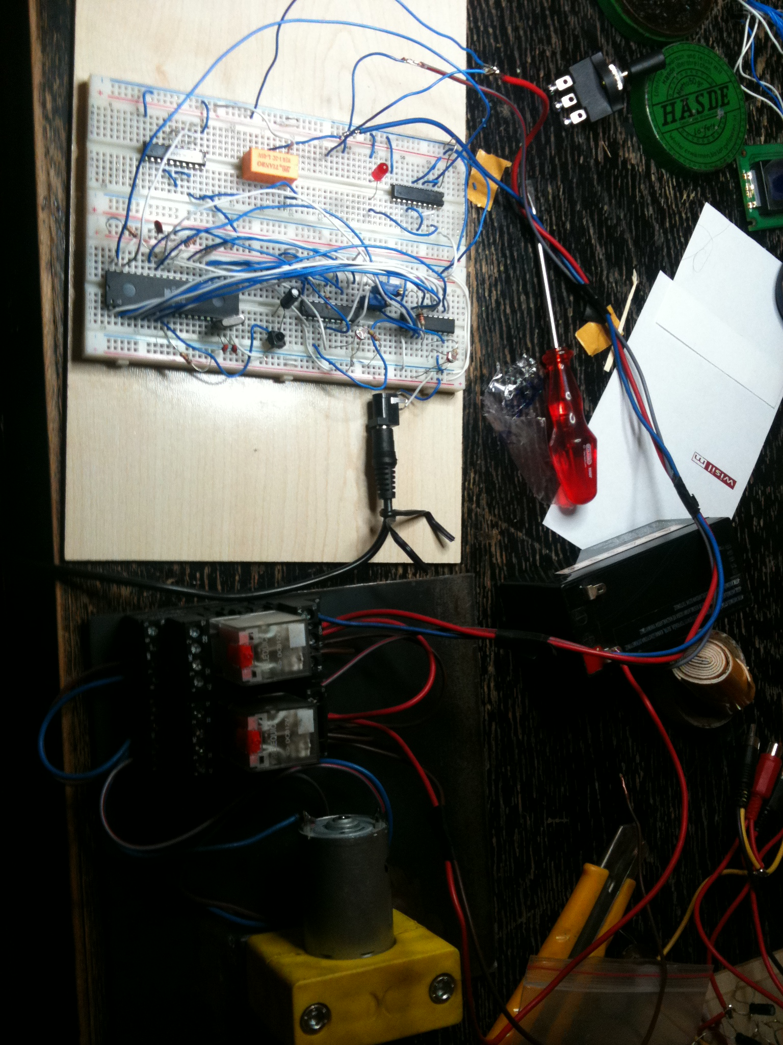
Figure 7: Prototype

WORKS CITED
http://ezinearticles.com/?Mutual-Non-Disclosure-Agreement-Template&id=350378
Previous reports’ works cited also applied to this final report.

